INSTRUCTION MANUAL FOR INCUBATOR
Air vent
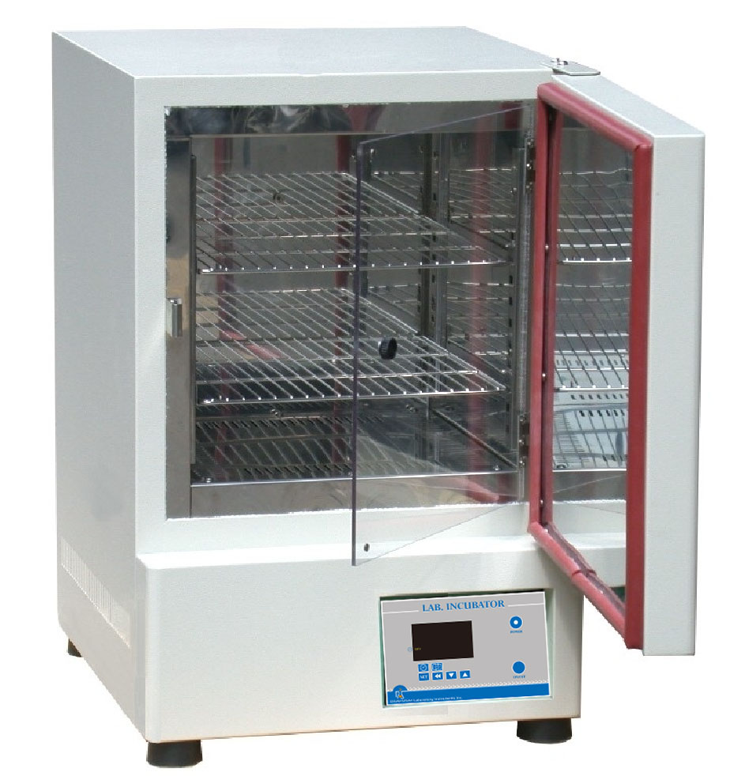
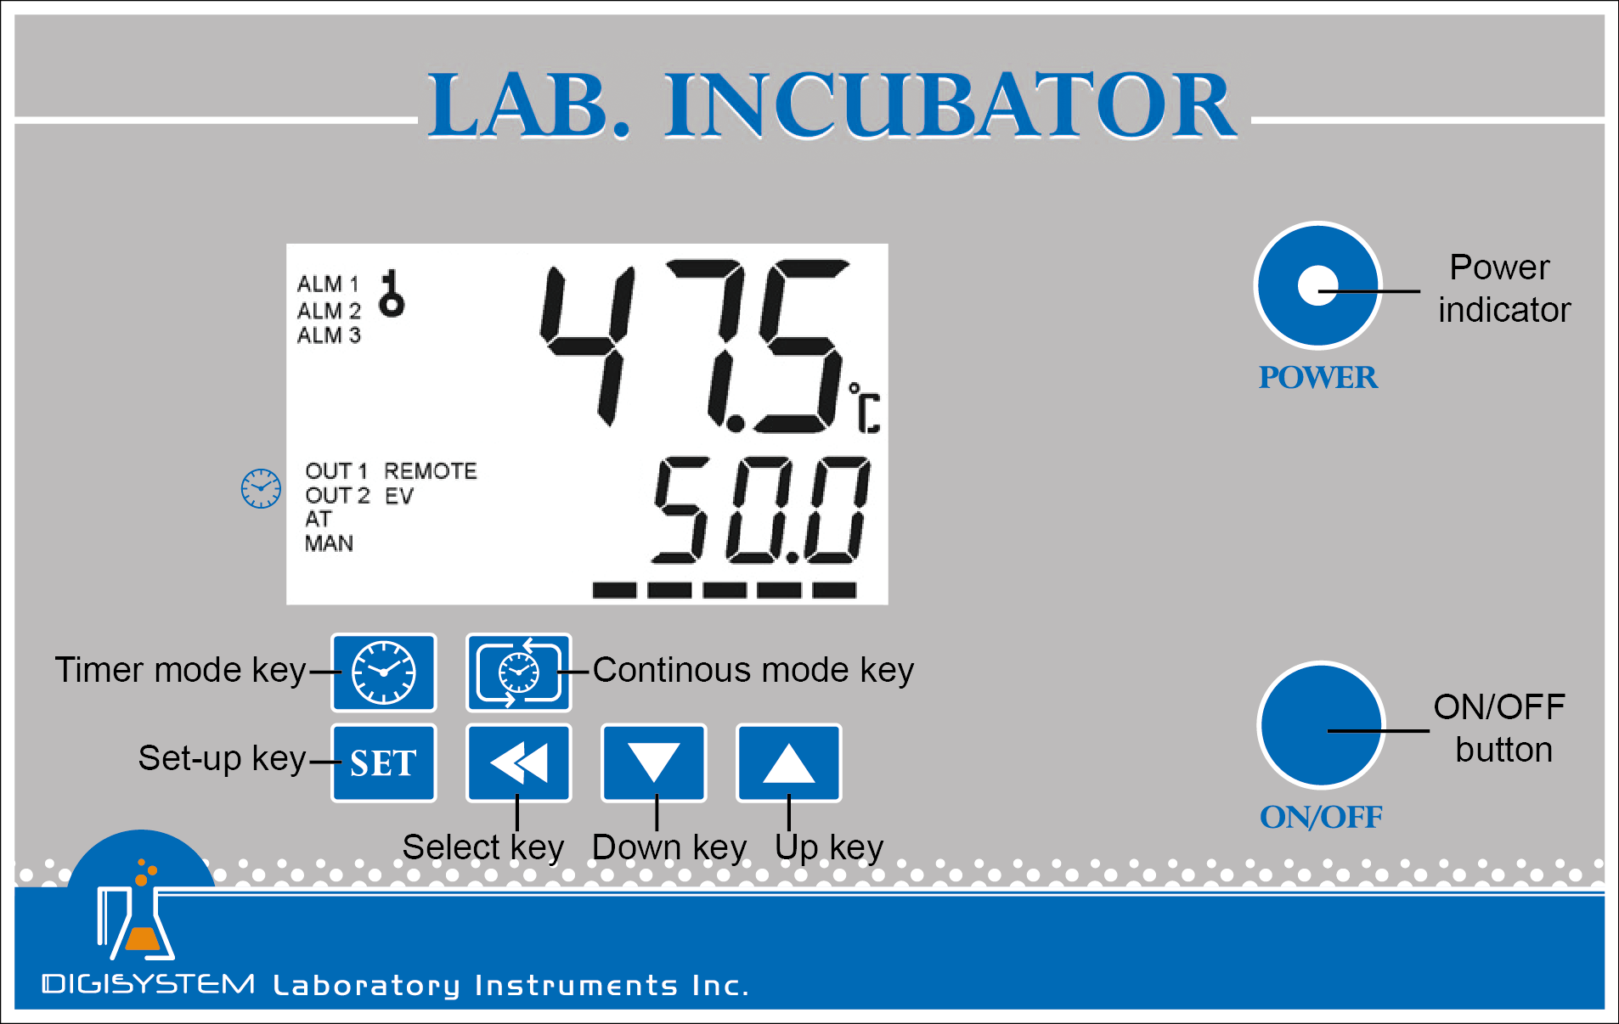

Controller
Controller

1. Connect with power supply. Please make sure the power voltage is the same as the voltage shown on the label stuck on the back of machine.
2. Put your sample in and close the door.
3. Press “ON/OFF Button”, then you will see the “Power indicator’ becomes green. Wait for about 5 seconds; you can see that on the display screen, the top row is the present temperature value (PV) and the bottom row is the setting temperature value (SV).
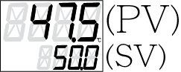


4. Set temperature: you will see . Press or to adjust SV value and then press to enter the value.



5. Set time: Select time mode: Continouos mode or Timer mode .

5.1 Press to set Continuous mode. OUT2 indicator on display screen will disappear. The setting is finished. Go to Step 6.

5.2 Press to set Timer mode. OUT2 indicator on screen will appear.


5.2.1 You will see or .

5.2.2 Use or key to select time unit  (hour) or  (minute). Press to enter the value. Press  to next setting.
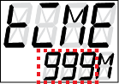
5.2.3 You will see . Use or key to adjust the time value. Press to enter the value. Press to next setting.
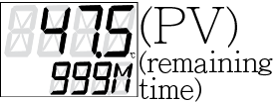
5.2.4 You will see . Press and you will see . The setting is finished.
Remark: If you want to interrupt the timer mode, you can press to be continuous mode.
6. After finishing the work, please press “ON/OFF Button” to turn off the power, and then the “Power indicator’ becomes red.

Caution:
1. Make sure that the door is closed well to prevent heat loss and power drain.
2. The surface is hot. Do not touch.
3. Do not put any objects on the top of the instrument.
4. Please keeps the environment ventilated.

Remark:
1. When the “OUT1” indicator on the display screen is sparkling, it means that the instrument is heating.
2. After the PV value reaches to SV value and tends to be stable, the “ALM1” indicator lamp will appear if the PV value exceeds the SV value by setting point (10℃). In this situation, please turn the power off, open the door and wait for about 30 minutes, and then restart it.
3. If you feel the PV value is much higher or lower than the SV value, you can adjust the “Air vent” to balance the temperature. That is, if the PV value is too high, you can open the “Air vent”; if the PV value is too low, you can close the “Air vent”.

Other functions:
Note: Before executing other functions , please make sure that the continuous mode is selected.
If you see OUT2 indicator on the screen, please press to set Continouos mode.
- Other functions include PV shift (offset) value, setting alarm point, setting temperature unit, auto tuning function.
Action | Display  (Initial value) | Explanation | Adjustment
Press |   (0) | PV shift (offset) value. If PV value is not correct, you can use this function to calibrate by your own thermometer. | Press or to adjust the value. Then press to enter the value.  If you want to go back to PV/SV display, press again.
Press |   (10) | Upper-limit point for alarm. When the difference between PV and SV is over upper-limit, the alarm indicator (ALM1) on display screen will be flashing.
Press |   (10) | Lower-limit point for alarm. When the difference between SV and PV is over upper-limit, the alarm indicator (ALM1) on display screen will be flashing.
Press |   (C) | Temperature unit. C or F.
Press |   (OFF) | Auto-tuning function. When auto-tuning function is on, the “AT” indicator” on display screen is flashing. When the function is off, the light of the “AT” indicator” is extinguish.
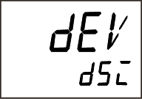
2. Restore default value:
  - Press more than 3 seconds, and then you will see 。
2.2 Press and then press , you will see is flashing. Please press to enter the value.
Then the default value is restored.

SERVICE MANUAL
Caution: Always disconnect the power cord before troubleshooting.
Trouble | Cause | Remedy
Instrument inoperative | Power cord not connected to outlet. | Plug instrument in..
Instrument inoperative | Dead power output. | Change to different output.
Instrument inoperative | No fuse Breaker is off | Press the breaker back of the machine, and check if the current is overload.
Instrument inoperative | Electronic element broken | Contact your distributor for repair.
Instrument inoperative | Power switch is broken | Replacing a power switch
Controller can’t control the temperature | Sensor is broken | Replacing a sensor
Controller can’t control the temperature | Controller | Replacing a Controller
Controller can’t control the temperature | Heater is broken | Replacing a heater
The key of PID controller can’t work | The keys has been locked | Please refer to the other function to release the lock status.
Temperature is not stable | The initial setting value is not suitable for the ambient air temperature where the machine is located | Refer to the other functions, execute the Auto-tuning function.
PV value is not correct | User’s calibration thermometer is different from the factory’s calibration thermometer | Refer to the other functions, execute the function for PV shift (offset) value.

Circuit diagram

